**TASK ANALYSIS AND USER FLOW USING LUCIDCHART**

**SAILOO S**

**230701277**

**Food Ordering Website User Flow Documentation**

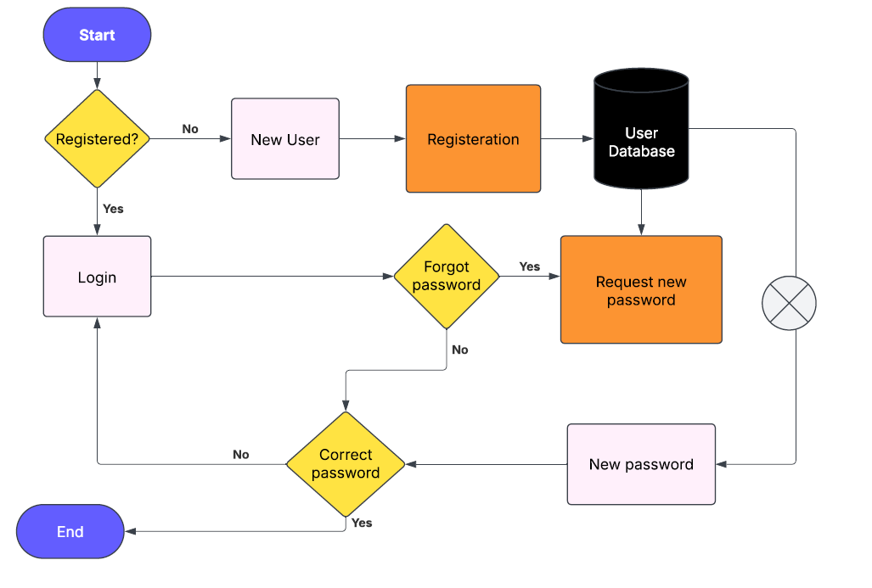

**1. Introduction**

**This document explains the user flow of a food ordering website, as depicted in the provided flow diagram. It outlines the sequence of actions a user takes from the starting point to completing the process. The document also elaborates on the meaning and function of the various shapes used in the flowchart.**

**2. Understanding Flowchart Shapes**

**Flowcharts use standardized shapes to represent different types of actions, conditions, and decisions. Here are the shapes used in the user flow:**

**a) Terminator (Start/End)**

* **Shape: Oval**
* **Function: Represents the beginning or end of a process.**
* **Usage in Diagram:**
  + **The flow starts with the "Start" point.**
  + **The flow ends after successful login or password reset failure.**

**b) Process**

* **Shape: Rectangle**
* **Function: Represents an action or operation to be performed.**
* **Usage in Diagram:**
  + **"Login" process for registered users.**
  + **"New User Registration" for unregistered users.**
  + **"Request new password" if a user forgets their password.**

**c) Decision**

* **Shape: Diamond**
* **Function: Represents a decision point with multiple outcomes.**
* **Usage in Diagram:**
  + **"Registered?" checks if the user is already registered.**
  + **"Correct password?" verifies if the entered password is correct.**

**d) Data Storage (Database)**

* **Shape: Cylinder**
* **Function: Represents a data storage point such as a database.**
* **Usage in Diagram:**
  + **Stores user information during registration.**
  + **Retrieves user data for login validation.**

**3. User Flow Explanation**

**The following section describes the step-by-step process of the user journey on the food ordering website as represented in the flowchart.**

**Step 1: Start**

**The process begins with the "Start" point. This is where the user initiates the interaction with the food ordering website.**

**Step 2: Registered User Check**

**A decision point determines whether the user is already registered:**

* **Yes: If the user is registered, they proceed to the login process.**
* **No: If the user is not registered, they are directed to the "New User Registration" process.**

**Step 3: Login Process**

**Registered users must provide their credentials to log in:**

* **Input username and password.**
* **Data is verified against the database.**

**If the password is correct:**

* **Yes: The process ends successfully.**
* **No: The user is given the option to request a new password.**

**Step 4: New User Registration**

**Unregistered users follow the registration process:**

* **Input necessary details (e.g., name, email, password).**
* **Data is stored in the database.**

**After registration, users can proceed to log in.**

**Step 5: Forgot Password Option**

**If a registered user forgets their password:**

* **Select the "Forgot Password" option.**
* **Request a new password.**

**Upon receiving the new password:**

* **Correct password: Allows successful login.**
* **Incorrect password: Users are prompted to try again or request another reset.**

**Step 6: End**

**The process ends after either successful login or failure to authenticate.**

**4. Conclusion**

**This documentation provides a detailed breakdown of the user flow for the food ordering website. Understanding the different flowchart shapes and their roles in the process helps in maintaining and improving the system's user journey. This flow ensures smooth user authentication and account management for the platform.**